1.

a) If we organize the names of 50000 products manually, it would take an extremely long time. Therefore, we should leave the task to a computer, which has more computing power to sort through all the names of the products.

b) We can create an algorithm to sort through the names alphabetically. One of the most efficient algorithms for this is QuickSort, based on the concept of Divide and Conquer, which has the time complexity of O(nlogn).

c) The minimum dimension should be 2x50000, which 2 columns for the ID and name of the products.

2.

a) What is the meaning of life? Can pigs fly?

b) Computers are machines which were made to product a precise and specific answer to questions. They do not take into account the question’s context, the possible metaphors or the hidden assertions. Humans can pass the Turing test in a way that a computer cannot because we are well aware of these factors.

c) Two possible ways are improving AI’s awareness of the context surrounding these questions or imitating the AI’s brain based on the human’s way of thinking.

3.

a) i) Reflex: Computer reads text and match the original to their translations in the database.

ii) Knowledge based: The thermostat must know when the temperature drops so it can adjust the settings.

iii) Goal based: Landing a plane requires following a set of procedures to achieve the goal of landing safely.

b) Procedural knowledge (learning “how”) or declarative knowledge (learning “what”).

Procedural knowledge: Playing chess.

Declarative knowledge: A car has four tires.

4.

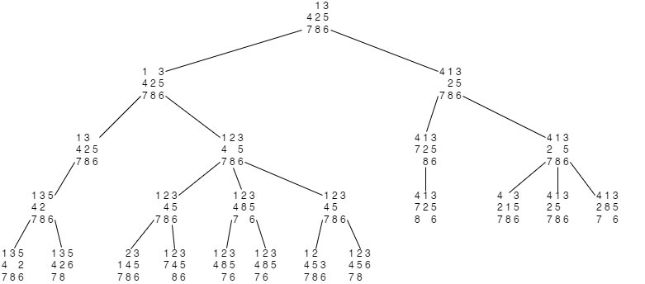a)

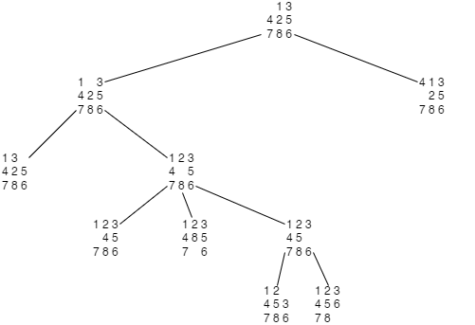b)

5.

a) Moore's Law was created only to describe the number of transistors that could be put on a chip for the least amount of money. The issue for chip designers is that Moore's Law is based on downsizing transistors, and physics will ultimately intervene. The length of a gate - the component of a transistor that switches the flow of electrons on or off - cannot be less than 5 nm due to electron tunneling. Heat extraction is another issue that smaller transistors face. The more transistors on a chip, the more heat it generates, and the more likely it is to fail. To prevent overheating, new technologies must be invented.

b) There are a lot of reasons for this phenomenon, which include the increased demand for electronics, global supply chain disruptions, the decline of traditional mining industries, natural disasters, geo-political climate, etc.